LAB EXPERIMENT
SET 26: STUDENT PERFORMANCE ANALYSIS

Department | AIDS
Course Code / Course Name | DSA0602 / Data Handling and Visualization
Experiment | Data Visualization using R and Tableau
Name | D.HEMASREE
Register Number | 192524114
Date | 20 October 2026
Day | Tuesday

Aim
To analyze student performance data using a histogram, a boxplot, a scatter plot with a regression line and a monthly trend chart with moving average in R, and to build an interactive dashboard using Tableau. Dataset: Student_Mini_Data.csv

Student_ID | Gender | Study_Hours | Attendance | Math_Score | Science_Score | Exam_Date
S01 | Male | 2.0 | 78 | 62 | 65 | 2025-01-10
S02 | Female | 3.5 | 90 | 80 | 85 | 2025-01-10
S03 | Male | 1.5 | 70 | 55 | 58 | 2025-02-12
S04 | Female | 4.0 | 95 | 90 | 92 | 2025-02-12
S05 | Male | 2.8 | 85 | 72 | 74 | 2025-03-15
S06 | Female | 3.0 | 92 | 82 | 86 | 2025-03-15

PROGRAM 1: Histogram of Math Score and Boxplot of Science Score by Gender
Import the dataset in R. Plot a histogram for Math_Score. Draw a boxplot of Science_Score by Gender. Add proper title and labels. Interpret the results.
students <- read.csv("Student_Mini_Data.csv") print(students)
summary(students$Math_Score) tapply(students$Science_Score, students$Gender, median)

hist(students$Math_Score,
breaks = seq(50, 100, by = 10), col = "steelblue",
border = "white", xlab = "Math Score",
ylab = "Number of Students",
main = "Histogram of Math Scores")

boxplot(Science_Score ~ Gender, data = students,
col = c("lightpink", "lightblue"), xlab = "Gender",

ylab = "Science Score",
main = "Science Score by Gender")

Console output

Student_ID Gender Study_Hours | Attendance | Math_Score | Science_Score | Exam_Date
1 S01 Male 2.0 | 78 | 62 | 65 | 2025-01-10
2 S02 Female 3.5 | 90 | 80 | 85 | 2025-01-10
3 S03 Male 1.5 | 70 | 55 | 58 | 2025-02-12
4 S04 Female 4.0 | 95 | 90 | 92 | 2025-02-12
5 S05 Male 2.8 | 85 | 72 | 74 | 2025-03-15
6 S06 Female 3.0  Min. 1st Qu. Median Mean  55.00 64.50 76.00 73.50 | 92  3rd Qu. 81.50 | 82  Max. 90.00 | 86 | 2025-03-15
Female Male
86 65

OUTPUT:
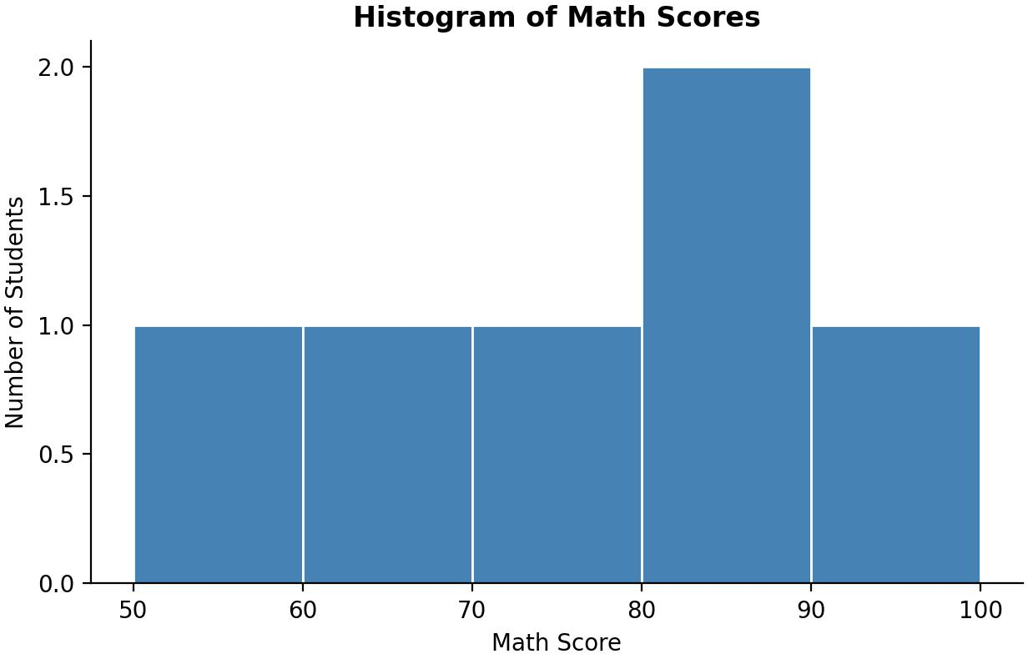

Output 1a: Histogram of Math Scores
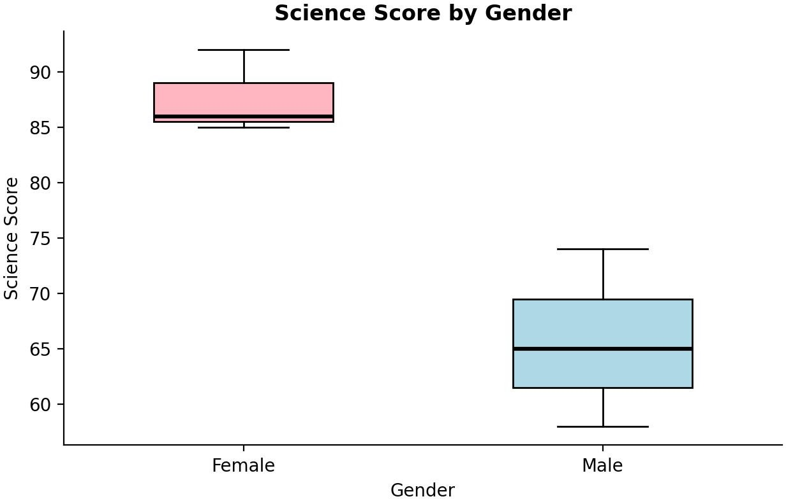

Output 1b: Boxplot of Science Score by Gender

Observation: Math scores range from 55 to 90 with a mean of 73.5 and a median of 76. Four of the six students score between 70 and 90, and one student scores below 60, which pulls the mean slightly below the median. In the boxplot, females have clearly higher Science scores: their median is 86 against 65 for males, and the two boxes do not overlap (females 85.5 to 89, males 61.5 to 69.5). No outliers are present. Each group has only three students, so the result is indicative only.

PROGRAM 2: Scatter Plot of Study Hours and Math Score
Create a scatter plot using R programming between Study_Hours and Math_Score. Use different colors for Gender. Add a regression line. Explain the relationship between study time and performance.
library(ggplot2)

ggplot(students, aes(x = Study_Hours, y = Math_Score)) + geom_point(aes(colour = Gender), size = 3.5) + geom_smooth(method = "lm", se = FALSE, colour = "black") + labs(title = "Study Hours vs Math Score",
x = "Study hours",
y = "Math score", colour = "Gender") +
theme_minimal()

fit <- lm(Math_Score ~ Study_Hours, data = students) print(round(coef(fit), 2))
r <- cor(students$Study_Hours, students$Math_Score) cat("Correlation:", round(r, 3), "\n")
cat("R-squared:", round(summary(fit)$r.squared, 3), "\n")

Console output
(Intercept) Study_Hours
34.89 13.79
Correlation: 0.973
R-squared: 0.947

OUTPUT:
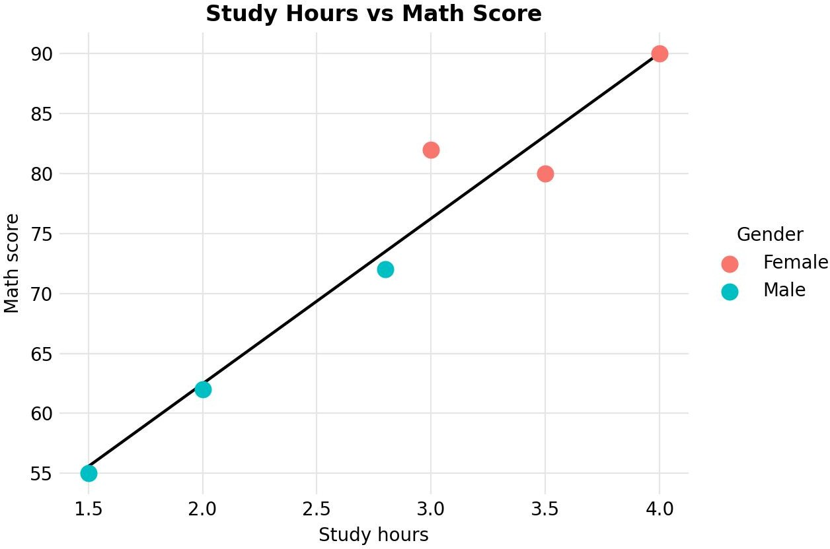
Output 2: Study Hours vs Math Score (Scatter Plot with Regression Line)

Observation: The points rise from the lower left to the upper right, so Math_Score increases with Study_Hours. The correlation is 0.973 and R-squared is 0.947, so about 95% of the variation in Math scores is explained by study time. The fitted line is Math_Score = 34.89 + 13.79 x Study_Hours, meaning each extra study hour goes with about 13.8 more marks. Female students (red) study more (3.5 hours on average against 2.1 for males) and score higher. This shows association, not proof of cause, and only six students are included.

PROGRAM 3: Monthly Average Math Score Trend with Moving Average
Using R, convert Exam_Date into Date format. Calculate monthly average Math scores. Plot a line chart for the trend. Apply moving average smoothing. Identify any increasing or decreasing pattern.
students$Exam_Date <- as.Date(students$Exam_Date) class(students$Exam_Date)
students$Month <- format(students$Exam_Date, "%Y-%m")

monthly <- aggregate(Math_Score ~ Month, data = students, FUN = mean) ma <- stats::filter(monthly$Math_Score, rep(1/2, 2), sides = 1) monthly$Moving_Avg <- as.numeric(ma)
print(monthly)
monthly$Month_Date <- as.Date(paste0(monthly$Month, "-01")) ggplot(monthly, aes(x = Month_Date)) +
geom_line(aes(y = Math_Score, colour = "Monthly average"), linewidth = 1) +
geom_point(aes(y = Math_Score, colour = "Monthly average"), size = 3) + geom_line(aes(y = Moving_Avg, colour = "2-month moving average"),
linetype = "dashed", linewidth = 1, na.rm = TRUE) + scale_x_date(date_labels = "%b %Y", date_breaks = "1 month") + labs(title = "Monthly Average Math Score",
x = "Month",
y = "Average Math score", colour = "") +
theme_minimal()

Console output

[1] "Date"  Month Math_Score |  | Moving_Avg
1 2025-01 | 71.0 | NA
2 2025-02 | 72.5 | 71.75
3 2025-03 | 77.0 | 74.75

OUTPUT:
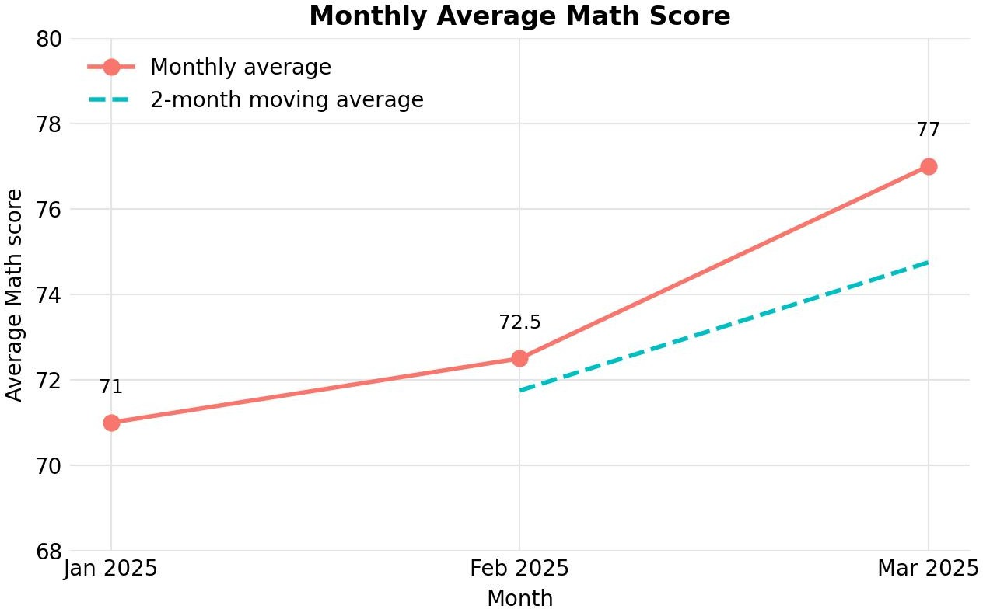
Output 3: Monthly Average Math Score with 2-Month Moving Average
Observation: The monthly average Math score rises from 71.0 in January to 72.5 in February and 77.0 in March, a gain of 6 points (about 8.5%) over the three months. The 2-month moving average also rises, from 71.75 in February to 74.75 in March, and it smooths the sharper jump of 4.5 points between February and March. The pattern is increasing, with no decreasing month. Each month has only two students, so the trend is indicative only.

PROGRAM 4: Interactive Student Performance Dashboard in Tableau
Import Student_Mini_Data.csv into Tableau. Create a bar chart showing average Math scores by Gender. Create a line chart for score trends over time. Add a filter for Exam_Date. Design a simple interactive dashboard.

Steps in Tableau
- Open Tableau and connect to the file (Connect > Text file > Student_Mini_Data.csv). Check that Exam_Date shows the Date data type; if it does not, click the data type icon above the field and choose Date.
- Sheet 1 (Bar Chart): Drag Gender to Columns and Math_Score to Rows, and change the aggregation to Average. Drag Gender to Color and add Math_Score to Label. Rename the sheet "Avg Math by Gender".
- Sheet 2 (Line Chart): Drag Exam_Date to Columns and choose Exact Date. Drag Math_Score to Rows (AVG) and set the Marks type to Line. Drag Gender to Color to show a line for each gender, and rename the sheet "Math Score Trend".
- Add the date filter: drag Exam_Date to Filters, choose Range of Dates, then right-click the filter, choose Show Filter and set Apply to Worksheets > All Using This Data Source.
- Create a new Dashboard (Dashboard > New Dashboard), set the size to Automatic, and drag the two sheets onto the dashboard area.
- Add interactivity: select the bar chart and click Use as Filter, so clicking a gender filters the line chart. Keep the Exam_Date filter on the dashboard.

- Add the title "Student Performance Dashboard" and test the filters in Presentation Mode.

OUTPUT:
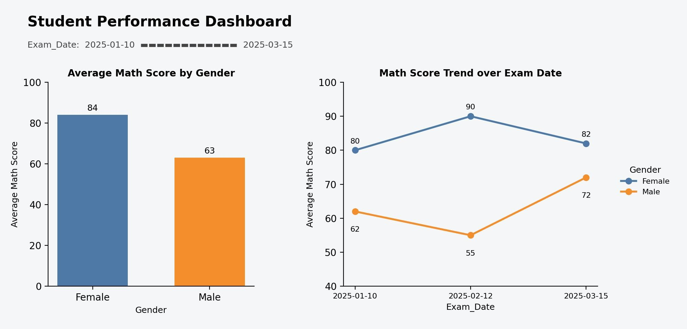
Output 4: Interactive Student Performance Dashboard (Tableau)
Observation: The dashboard shows the average Math score by gender (Female 84, Male 63) beside the trend of average Math scores over the exam dates. Moving the Exam_Date filter or clicking a gender updates both views, so performance can be explored by gender and by time.

Procedure
- Import the CSV file into R with read.csv() and view the data.
- Use hist() to plot the Math_Score histogram and boxplot() to plot Science_Score by Gender.
- Use ggplot2 with geom_point() and geom_smooth(method = "lm") to draw the scatter plot with a regression line, and use lm() and cor() to measure the relationship.
- Convert Exam_Date with as.Date(), find monthly averages with aggregate(), and apply a moving average with stats::filter().
- Plot the monthly averages and the moving average as line charts with ggplot2.
- Load the CSV file into Tableau, build the bar chart and line chart worksheets, and combine them in a dashboard with an Exam_Date filter and actions.

RESULT:
The student performance data was successfully analyzed in R using a histogram, a boxplot, a scatter plot with a regression line and a monthly trend line with moving average. An interactive Tableau dashboard was also created, combining the bar chart and line chart with an Exam_Date filter so that users can explore the scores by gender and over time.

Key Functions and Tools Used

Function / Tool | Purpose
read.csv() | Imports the dataset into R.
hist() / boxplot() | Creates the histogram and the boxplot.
ggplot() / geom_point() / geom_smooth() | Creates the scatter plot with a regression line.
lm() / cor() | Fits the regression line and measures the correlation.
as.Date() / aggregate() | Converts dates and calculates monthly averages.
stats::filter() | Applies moving average smoothing.
Tableau Dashboard | Combines worksheets with filters and actions.

